IOTs Based Stepper Motor Control using ARDUINO
M. VENKATESAN
Department of Electrical and Electronics Engineering, Vignan’s Lara Institute of Technology and Science
venkatesangct@gmail.com
Abstract:
In this modern era, electric motors are widely used in many fields of engineering and also every part of our daily life. Specific types of electric motors are designed to meet particular applications. In this paper, step size of the stepper motor control using Arduino processor through Internet is presented. The main objective of this paper is to design and control the stepper motor from remote places using Smart mobile phone. Blynk webpage application has been developed for the internet of Things (IoTs) and it is able to control the step size of the stepper motor from remotely. The proposed stepper motor control using IoTs is validated through real time implementation using Ardunio board and webpage is maintained with the help of web content management.

Key words : Arduino, Stepper motor, IOT, blynk , webpage.

- INTRODUCTION

Technology is growing at an unbelievable speed. In today’s modern world everything is automatic. The one which finds major application in this electronic world is stepper motor. The powerful computer is the corner stone for any successful business and industry in today’s turbulent and rapid changing environment [1]. This leads to the explosive growth of computer industries. Due to this, there has been widespread demand of stepper motors. Stepper motors are used in various fields like industrial machinery, robotics, computer peripherals, business machines, motion control, and medical instrumentations [2-4]

A stepper motor is an electromechanical motor which converts mechanical power from given electrical input power. There are three types of stepper motors [5] such as variable reluctance stepper motor (VR) ii) permanent magnet stepper motor iii) Hybrid stepper motor. A variable reluctance stepper motor has many advantages such as no permanent magnet, no cogging torque and high stepping capability. However, it produces more vibrations; smaller step size is not possible and complex control circuits [6]. Due to this, VR stepper motor may not be suitable for precise control applications. Bigger step size, fixed rated torque, limited power and size are drawbacks of the permanent magnet stepper motor. The hybrids stepper is a combination of VR and Permanent magnet stepper motor to obtain the optimal power with small size of the motor. In recent years, most the industries and researcher are preferred for hybrid stepper motor because, it is able to operate open loop mode, smaller step size and no cumulative position error [7]. But today’s peoples are expecting faster and small size, higher operating efficiency, reliability and low cost. In recent days, the stepper motor controlled the Micro controller [8-9]. However, more time requires for development of circuit board and this increases cost. Due to the technology growth, everyone would like to control their electrical appliance through internet and smart mobile phones.

In this proposed system is aimed to meet three objectives. The objectives are (i) To develop a webpage control for a stepper motor using Arduino. (ii) To control the stepper motor speed (i.e) increase or decrease. (iii) To control the stepper motor direction in clockwise or anti-clockwise. The proposed stepper motor control using IoTs is validated through real time implementation using Ardunio board and webpage is maintained with the help of web content management.

2. Block Diagram of Proposed System
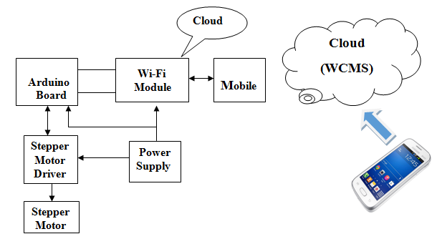
Figure 1 Block diagram of proposed system

3.1 Blynk Application Developments
Blynk application has been designed for the IOTs. It can control the stepper motor from remotely. It is displays sensors and stored data. There are three major components in the platform such as
- Blynk App - allows us to create amazing interfaces for the hardware using various widgets provided.
- Blynk Server – It is responsible for all the communications between the smart phone and hardware. Use Blynk Cloud or run our private Blynk server locally. It’s open-source, could easily handle thousands of devices and can even be launched on a Raspberry Pi.
- Blink Libraries – It is a popular hardware platforms enable s with server and process all the incoming and outgoing commands.

Figure 2 BLYNK application

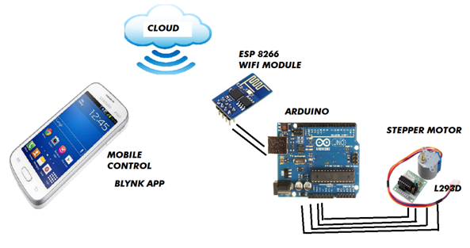
Figure 3 Graphical representation of proposed IOTs based stepper motor control
3.2 Operating Principle
The stepper motor cannot be controlled directly from the controller. So it is controlled through stepper motor driver circuits. The ULN2003 stepper motor driver circuits is used in this experimental setup. Controller, stepper motor driver and Wi-Fi module are powered by power supply unit. The smart Mobile phone is connected to WI-FI because blynk android application is accessed from android operating system. Web page shows the present stepping angle of stepper motor. When change the stepping angle of stepper motor in webpage (i.e) from blynk android mobile app. It is send to the ESP8266 through Wi-Fi and controller reads the step size. From the controller command is send to stepper motor driver. Then, finally driver controls the stepping angle of the stepper motor. The main advantage in this system is it is possible to control the stepping angle of stepper motor from anywhere in the world with the help of android mobile.

3.3 Implementation of IoTs Based Stepper Motor
The proposed system has been implemented using Arduino development board and verified in real time environment.
Arduino
Arduino/Genuino Uno is a microcontroller board based on the ATmega328P. It has 14 digital input/output pins (of which 6 can be used as PWM outputs), 6 analog inputs, a 16 MHz quartz crystal, a USB connection, a power jack, an ICSP header and a reset button. It contains everything needed to support the microcontroller; simply connect it to a computer with a USB cable or power it with a AC-to-DC adapter or battery to get started.
Power supply
The Arduino/Genuino Uno board can be powered via the USB connection or with an external power supply. The power source is selected automatically. External (non-USB) power can come either from an AC-to-DC adapter (wall-wart) or battery. The board can operate on an external supply from 6 to 20 volts and acts as a source for all other components.

Wi-Fi Shield ESP8266
The ESP8266 module is a IoT device consisting of a 32-bit ARM microprocessor with support of Wi-Fi network and built-in flash memory. This architecture allows it to be programmed independently, without the need of other microcontrollers like the Arduino. The module can even be reprogrammed to act as a standalone WiFi connected device–just add power.

Node MCU Platform

Node MCU is a complete environment of hardware and software for IoT prototyping consisting of the following items:
  - Controller board consisting of a ESP8266 module
  - Micro USB Port to power (5 volts) and programming
  - 10 digital inputs GPIOs operating at 3.3V and an analog input GPIO to 1.8 V
  - Development kit based on the Lua language
The Node MCU programming can be as easy as in Arduino. NodeMCU is a firmware that allows you to program the ESP8266 modules with LUA script. And we’ll find it very similar to the way we program our Arduino. With just a few lines of code we can establish a Wi-Fi connection, control the ESP8266 GPIOs, turning our ESP8266 into a web server and a lot more.

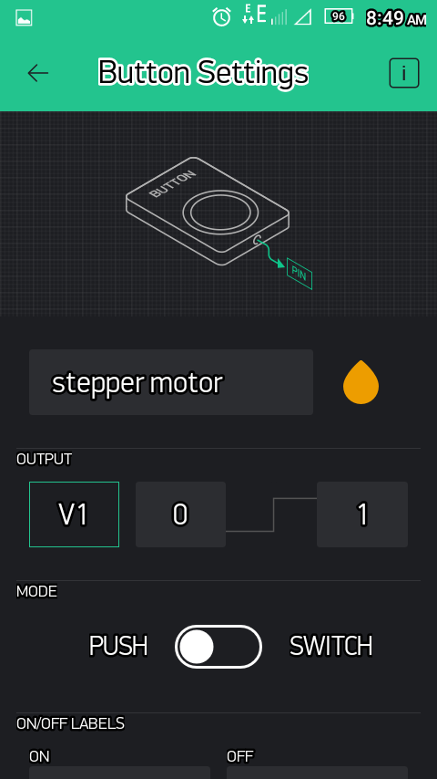
Figure 4 Webpage image
Table 1 Set step vs Angle in degree
Set steps | Angle in Deg. | Time in ms
50 | 7.2 | 200
40 | 9 | 280
30 | 12 | 350
20 | 18 | 435
10 | 36 | 590
5 | 72 | 710

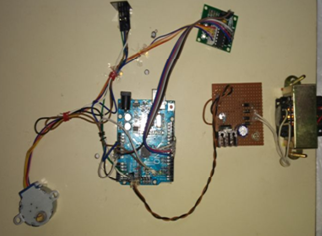

Figure 5 Photo copy of Experiment setup

5. CONCLUSION

In this paper stepping angle of stepper motor is controlled through android application from webpage. It is very useful in today’s modern world because stepper motors are used in various fields like industrial machinery, robotics, computer peripherals, business machines, motion control, medical, various process-control and machine-tool applications and more. But in every field the stepping action is varied accordingly to the requirements. So by controlling it from webpage anywhere in the world it reduces the maintenance cost. The proposed system has been implemented using Arduino board using IOTs.

REFERENCES
[1] Barhoumi EM, 2 Ben salah B New Positioning Control of Stepper Motor using BP Neural Networks, Journal of Emerging Trends in Computing and Information Sciences, Volume 2 No.6, June 2011.

[2] Jufer M, Electromécanique. Presses polytechniques Lausanne. 1995

[3] Kant M Les actionneurs électriques pas à pas. Edition Hermès Paris. 1989

[4] Kyu son Y, Lee J Comparison between Two Types of PM Stepping Motor Using Finite Element Analysis. Proceeding of International Conference on Electrical Machines and Systems. Korea., 2007.
[5] Acarnley, "Stepping motors-a guide to theory and practice," 4th Edition, the Institution of Electrical Engineering, London, 2002

[6] Ivan Virgala , Michal Kelemen, Alexander Gmiterko, Tomáš LiptákControl of Stepper Motor by Microcontroller , Journal of Automation and Control, Vol. 3, No. 3, pp.131-134, 2015,

[7] K. Balakrishnan, “Identification of Resonance in Hybrid Stepper Motor Through Measured Current Dynamics in Online for Accurate Position Estimation and Control,” IEEE transaction on industrial informatics, vol. 9, no. 2, may 2013.

[8] Pawan Chandra, Piyush Anand, Prabhat Chandra Chantola & Shilpi , GSM Based Stepper Motor Monitoring and Speed Control, , ITSI Transactions on Electrical and Electronics Engineering, 2320 – 8945, Volume -1, Issue -5, 2013.

[9] Stepper Motor Precise Position Control System Using DTMF Technology, International Journal on Recent and Innovation Trends in Computing and Communication, Volume: 3 Issue: 5, May 2015

